NET FA3 WEEK 5

NHLANHLA J NKOSI
20232271
BOKSBURG Campus

TASK 1
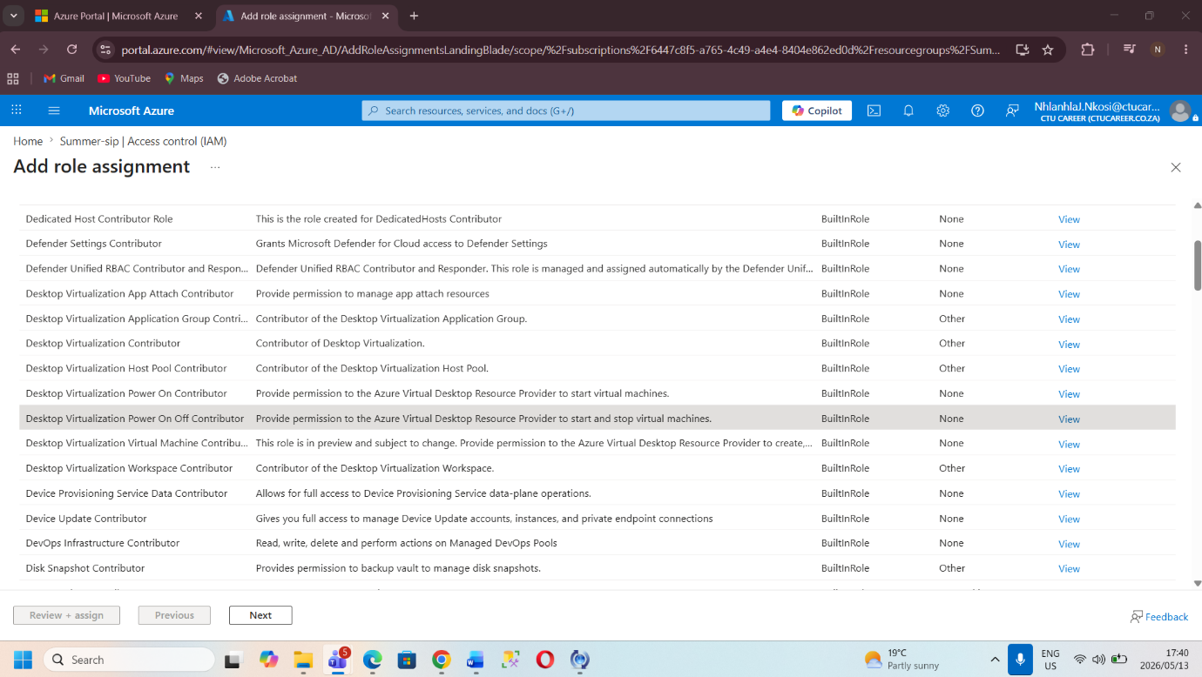
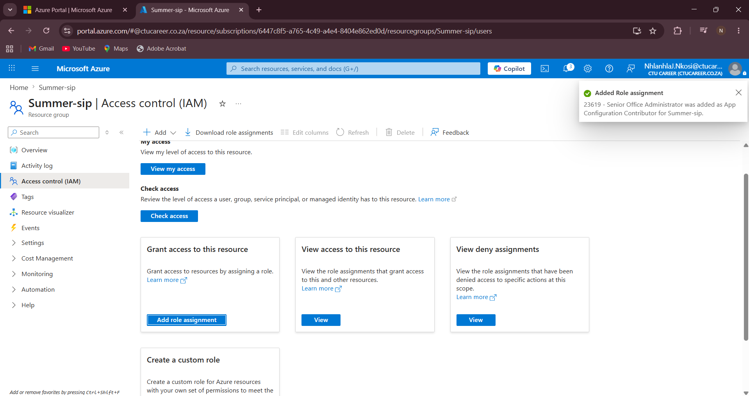

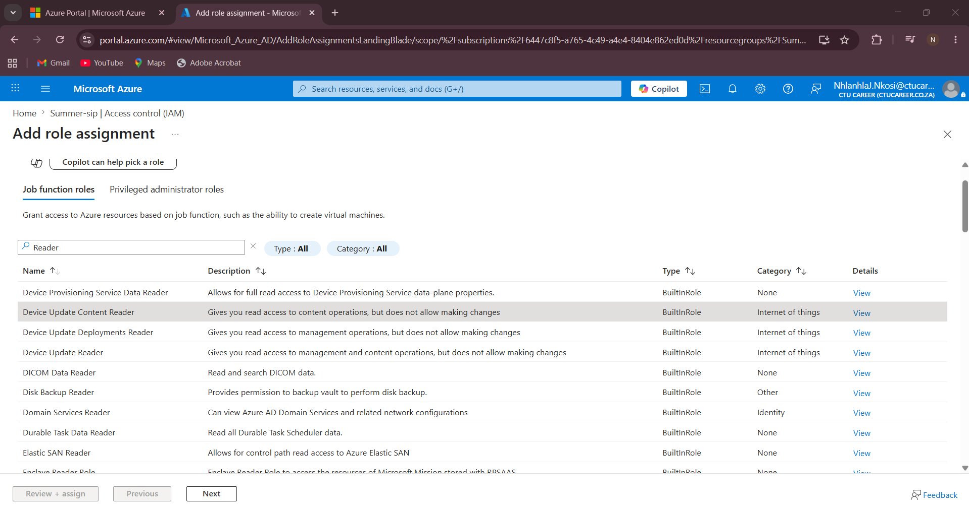
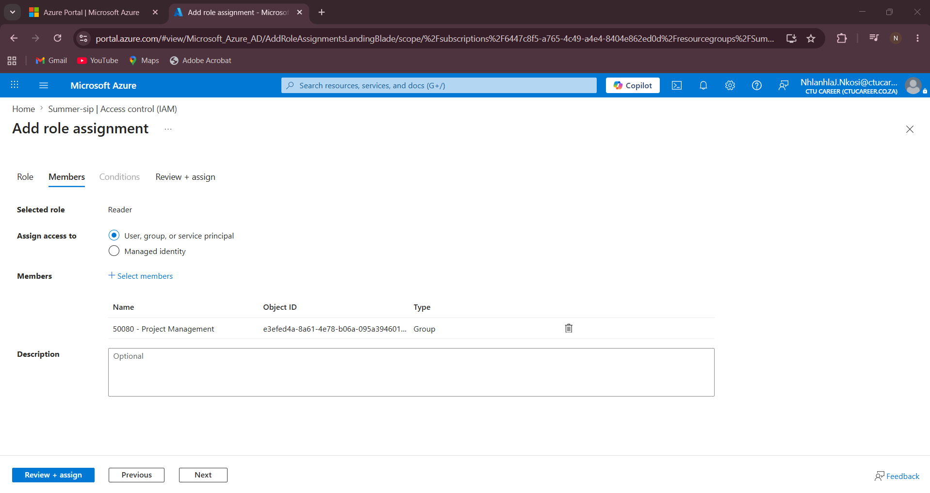

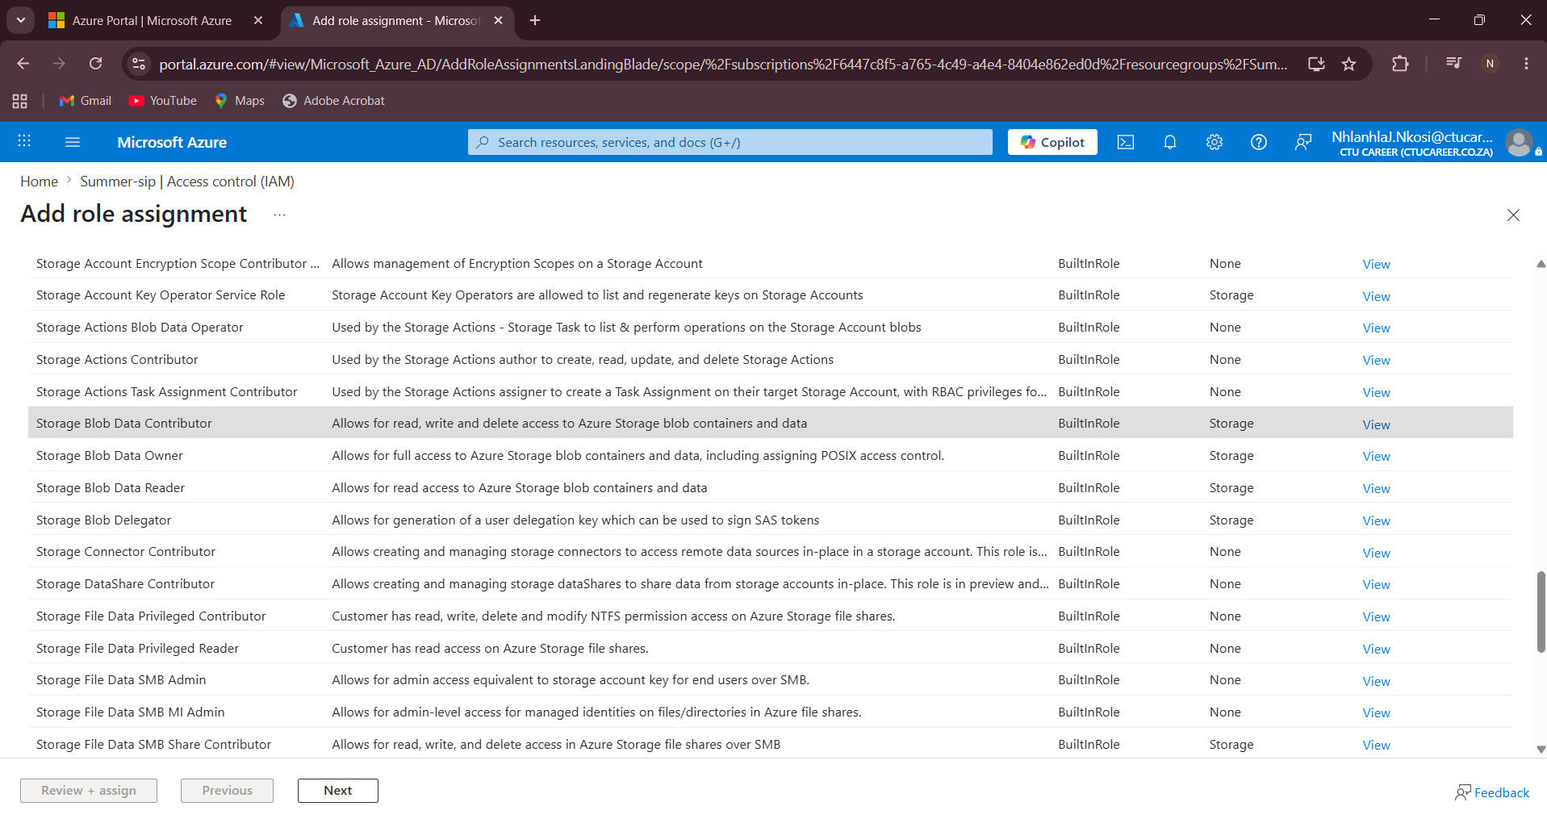
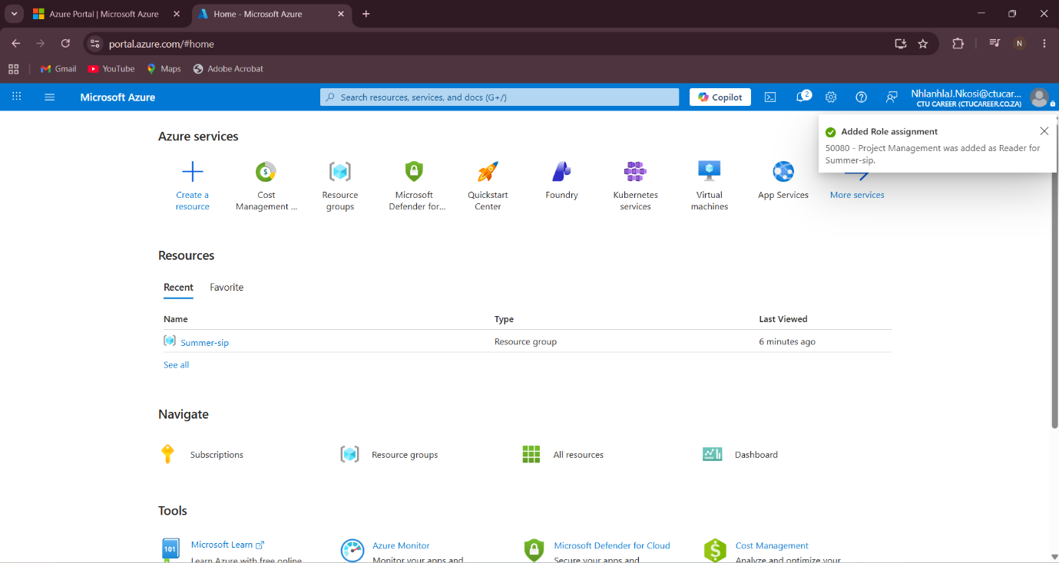

Task 2 -Network Security group

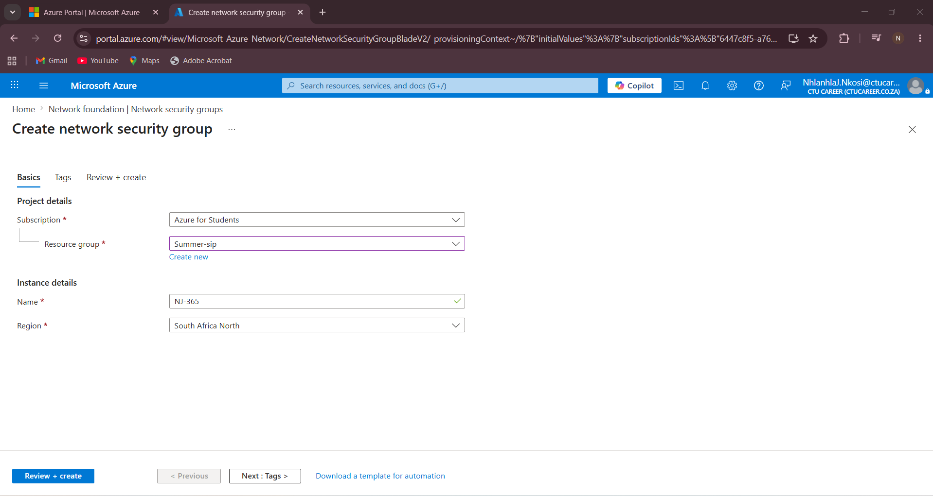

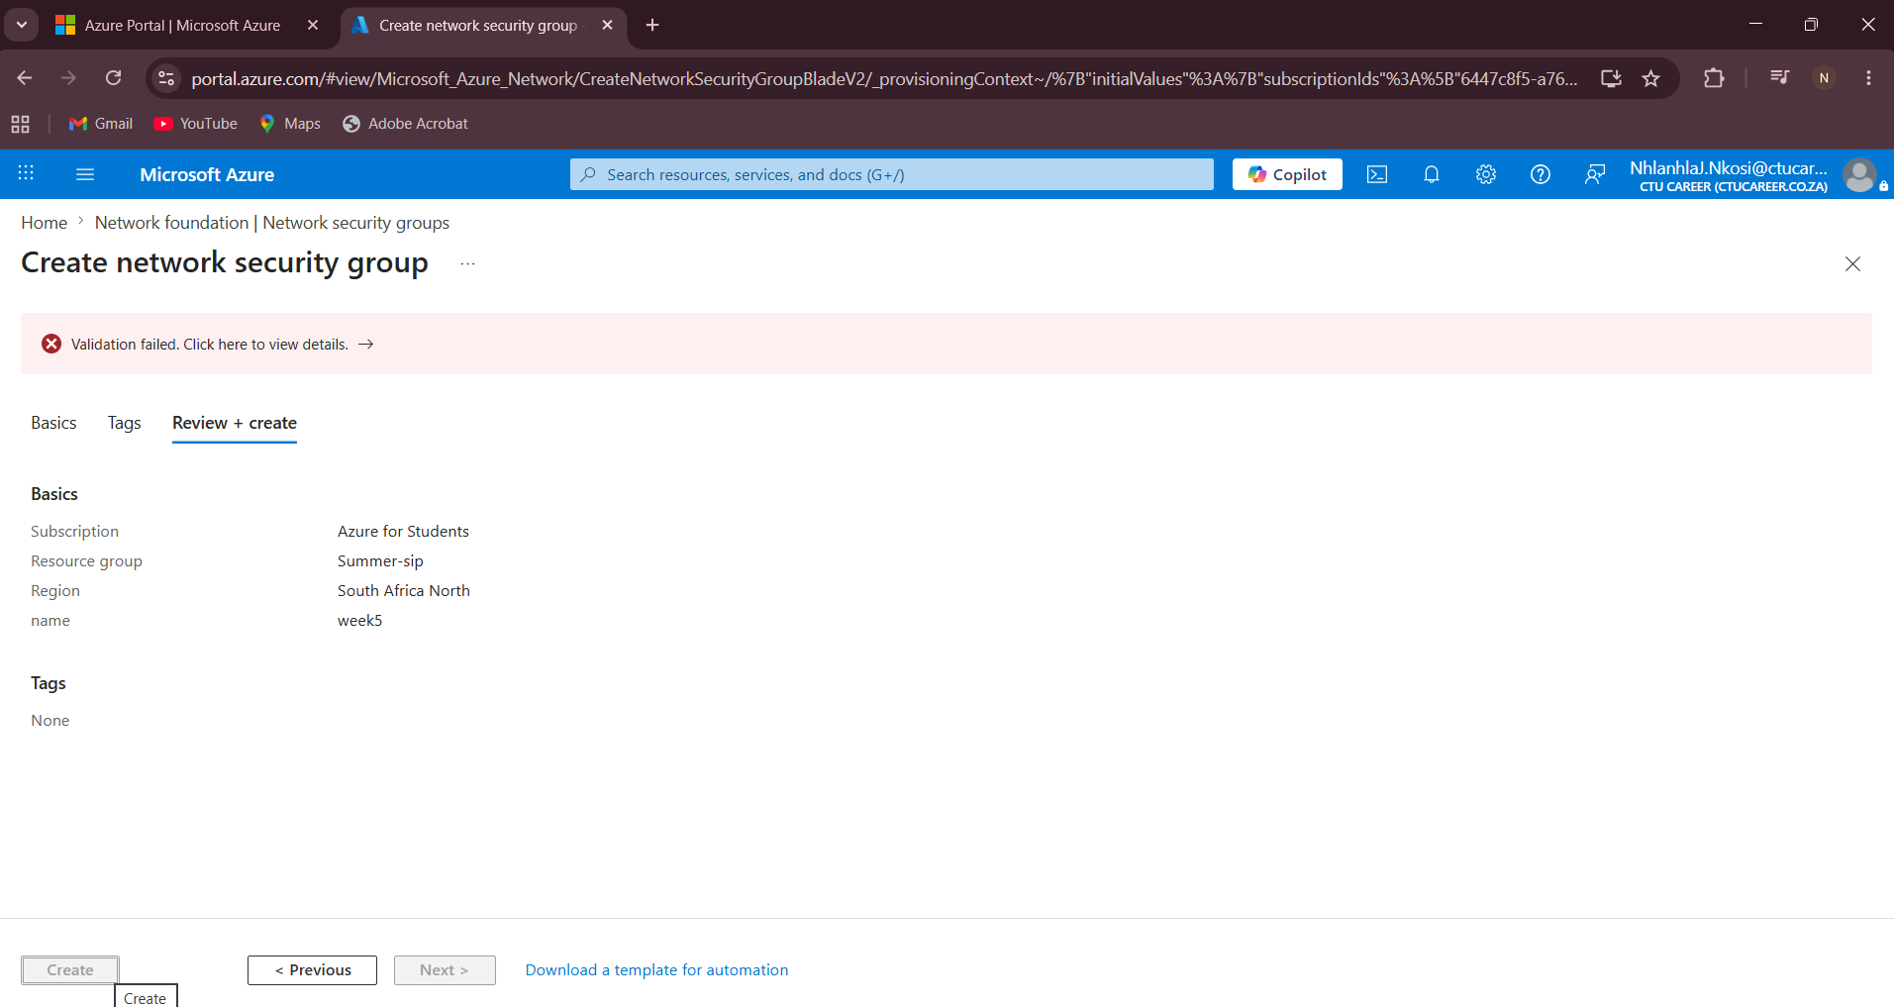
For this task, I created and configured a Network Security Group (NSG) to control inbound and outbound traffic to Azure resources. The NSG helps protect virtual machines and network resources from unauthorized access.
the Steps I will do:
- Azure Portal and searched for “Network Security Groups”.
- Clicked “Create” to create a new NSG.
- Entered the NSG name, selected the Resource Group, and chose the correct region.
- Clicked “Review + Create” and selected “Create”.
- Opened the created NSG and selected “Inbound Security Rules”.
- Added a rule to allow SSH or RDP traffic for remote access.
- Configured the source, destination, protocol, and port number.
- Another rule is added to deny unnecessary traffic for better security.
- Associated the NSG with the virtual machine subnet or network interface.
- Tested the configuration to ensure the correct traffic was allowed or blocked.

Task 3 – Storage account and containers
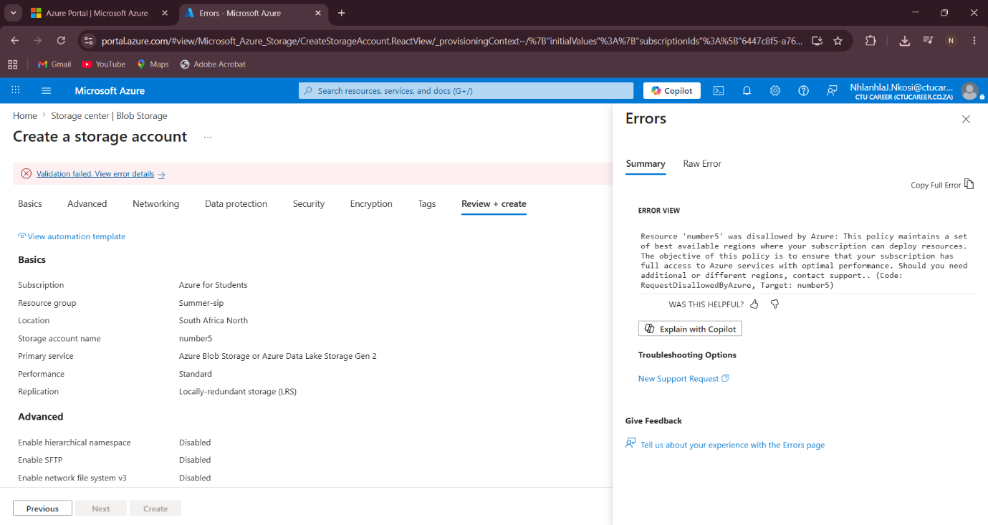
In this task, I was going to create a Storage Account and configured Blob Containers for storing files. The storage account was configured for a general-purpose internal file repository.
Steps I will do:
Opened the Azure Portal and searched for “Storage Accounts”.
- Clicked “Create” to create a new Storage Account.
- Entered the Storage Account name and selected the correct Resource Group and region.
- Selected Standard performance for cost effectiveness and reliability.
- Selected Locally Redundant Storage (LRS) because it is suitable for internal business data and is cost effective.
- Selected the Hot access tier because the files would be accessed frequently.
- Clicked “Review + Create” and selected “Create”.
- Opened the Storage Account and selected “Containers”.
- Created two blob containers named “internal-docs” and “public-assets”.
- Uploaded sample files into each container to test storage functionality.

